Name:- Mehul Vinod Gohil

Roll No:-14 fyIT

***Introduction and contribution to Wikipedia***

***Introduction:-***

Since its debut in 2001, Wikipedia has grown to be a very popular and well-known online resource. All of the content on the site I created and edited by and offered under a creative commons attribution /sharelaike 3.0 license.it has:

Over 4.6 million articles;

Over 33.9 million pages;

Over 22.7 million user account with 73,251 active user a of May 2014.

***Contributing:-***

Wikipedia is the six most popular website in the world and we almost all use it. But, do you know how to contribute to it? This guide will help you to get started making edit and additions to Wikipedia and uploading content to Wikimedia commons.

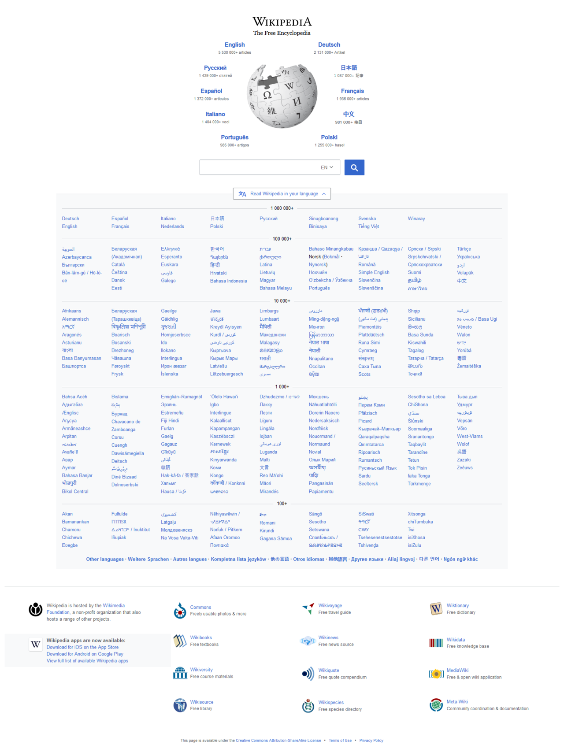

1. ***Description about Wikipedia and it’s features***

Wikipedia I a free, open content online encyclopedia created through the collaborative effort of a community of users known as Wikipedians. Anyone registered on the site can create an article for publication; registration is not reuired to edit article .Wikipedia only non commercial site of the top ten.

***Basic features of a Wikipedia***

1. Create a page.
2. Edit a page .
3. Link between pages.
4. **Creating Account on Wikipedia.**

Steps are given below:-

If you decide to create account, the process is very streamlined. You will need to select a username and a password. But that is only information that is required. You have the option to supply an email address, which I needed to receive email notification or rest your password if you lose it. You can see the “create Account” below.

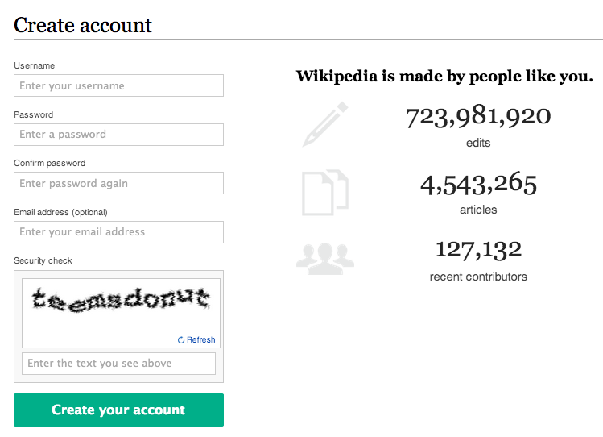

1. **Create a page**

To contribute to a Wiki, you'll start by creating a page. All pages have a title and text. Unlike pages of a normal website, you won't need to know any code to contribute content here. You can write and format text on a Wiki page like you would an email.

When you're done, all you have to do is click “Submit” to save the page and it can immediately be read by anyone.

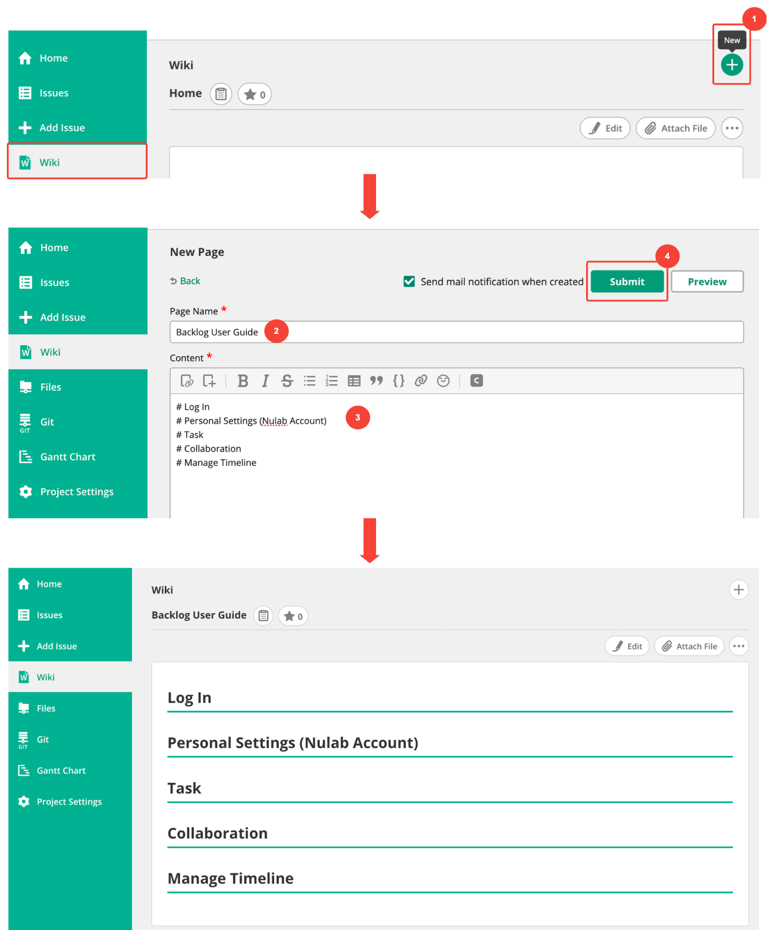

1. ***Edit a page***

Published pages can be edited by anyone that reads them. If, for example, you notice that a page created by someone else contains inaccurate/outdated information, you can open the editing screen and correct that information directly. Just “Submit”, and the page's contents will update immediately.

